***Microprocessors and Microcontrollers***

BECE204L

**Semester:** Fall 2024-2025

**Slot:** G2

**Faculty:** Dr. S. Revathi

|  |  |
| --- | --- |
| **Register Number** | **Name** |
| 24BCE1618 | Shreyas Kulkarni |
| 24BCE1604 | Atharva Deshpande |
| 24BCE1117 | Karan Gandhi |
| 24BCE1095 | Ansh Sharma |

|  |  |  |  |
| --- | --- | --- | --- |
| **Rubrics** | **Max. Marks** | **Scored Marks** | |
| Proteus Simulation | 5 | 24BCE1618 |  |
| 24BCE1604 |  |
| 24BCE1117 |  |
| 24BCE1095 |  |
| Hardware Working model | 10 | 24BCE1618 |  |
| 24BCE1604 |  |
| 24BCE1117 |  |
| 24BCE1095 |  |
| Report in format | 5 | 24BCE1618 |  |
| 24BCE1604 |  |
| 24BCE1117 |  |
| 24BCE1095 |  |

Faculty Signature

|  |  |
| --- | --- |
| **SERIAL NUMBER** | **CONTENT** |
| **1** | **Introduction** |
| **2** | **Component List** |
| **3** | **Connection** |
| **4** | **Assembly Code and Simulation** |
| **5** | **OutCome** |

# *Introduction*

Our project introduces an intelligent Energy Conservation System designed to automatically manage electrical appliances and reduce electricity wastage in real-time. The system's primary goal is to ensure that lights, fans, and other devices are only powered on when a room is occupied. At the heart of this system is the AT89C51 microcontroller, which acts as the central brain, processing inputs from sensors and controlling the power flow to appliances.

The core of the system is an automated, bi-directional people counter. To achieve this, two Infrared (IR) obstacle sensors are strategically placed: one at the entry gate and one at the exit. The entry sensor is connected to the external interrupt pin INT0 (P3.2), while the exit sensor is connected to INT1 (P3.3). When a person enters the room, the entry sensor detects the motion and triggers a hardware interrupt, causing the microcontroller to immediately run a specific routine to increment the person count. Similarly, when a person leaves, the exit sensor triggers the INT1 interrupt, and the microcontroller decrements the count. This interrupt-driven method is highly efficient, as the microcontroller doesn't waste resources by continuously polling the sensors; it only acts when an event occurs, guaranteeing no person is missed.

The system's energy-saving logic is directly tied to this live count, which is displayed on a 16x2 LCD screen for visual feedback. The LCD is interfaced in 8-bit mode using Port 2 for fast data transfer. The microcontroller continuously checks the stored count variable. If the count is zero, it signifies the room is empty, and the microcontroller automatically sends a signal to turn OFF all connected electrical appliances (represented by the fan and LED in the circuit). The moment the count becomes one or more, the system powers the appliances ON. This smart, automated control effectively eliminates human error and ensures that electricity is consumed only when genuinely needed, making it a practical solution for energy conservation in homes, offices, and classrooms.

# *Component List*

* AT89C51ED2: Microcontroller
* ISP Programmable Board
* 16x2 LCD
* Servo Motors
* IR-sensor
* Potentiometer
* Resistor
* Jumper Wires
* LEDs
* Breadboard
* Batteries

# *Connection Pin Diagram*

1. **AT89C51ED2**
   * + Port P2 connected to LCD
     + Port P3.2 to IR sensor connected to Entry gate
     + Port P3.3 to IR sensor connected to Exit gate
     + Port P3.5 to Enable pin of LCD
     + Port P3.7 to Register Select pin of LCD
     + Port P1.0 to LED
     + Port P1.1 to Servo Motor Signal pin of Entry gate
     + Port P1.2 to Servo Motor Signal pin of Exit gate

**2. 16x2 LCD**

* + - D0 - D7 to Port P2 of Microcontroller
    - Enable pin to Port P3.5 of Microcontroller
    - Read/Write pin is grounded
    - Register Select pin to Port P3.7 of Microcontroller
    - VEE pin to Middle pin (Wiper) of Potentiometer
    - VDD pin to VCC
    - VSS pin is grounded

**3. Servo Motor of Entry Gate**

* + - First pin is grounded
    - Middle pin is connected to Port P1.1 of Micro-controller
    - Last pin is connected to VCC

**4. Servo Motor of Exit Gate**

* + - First pin is grounded
    - Middle pin is connected to Port P1.2 of Micro-controller
    - Last pin is connected to VCC

**5. IR Sensor of Entry Gate**

* + - First pin is connected to Port P3.2 of Micro-controller
    - Middle pin is grounded
    - Last pin is connected to VCC

**6. IR Sensor of Exit Gate**

* + - First pin is connected to Port P3.3 of Micro-controller
    - Middle pin is grounded
    - Last pin is connected to VCC

**7. LED**

* + - Positive pin is connected to Port P1.0
    - Negative pin is grounded

# *Assembly Code*

ORG 0000H

SJMP MAIN

ORG 0003H

LJMP ENTRY_ISR ; INT0 -> Entry

ORG 0013H

LJMP EXIT_ISR ; INT1 -> Exit

servo1_flag EQU 30H

servo2_flag EQU 31H

count EQU 32H

last_entry EQU 33H

last_exit EQU 34H

MAIN:

ACALL LCD_INI

MOV TMOD, #11H

MOV IE, #85H

SETB TCON.0

SETB TCON.2

MOV IP, #00H

CLR IE0

CLR IE1

MOV P1, #00H

MOV servo1_flag, #00H

MOV servo2_flag, #00H

MOV count, #00H

MOV last_entry, #00H

MOV last_exit, #00H

MOV DPTR, #MSG2

ACALL DISP_STRING

ACALL DELAY_20MS

MOV A, #01H

ACALL CON_SUB

ACALL DELAY_20MS

SJMP MAIN_LOOP

MAIN_LOOP:

MOV A, #01H

ACALL CON_SUB

ACALL DELAY_20MS

MOV DPTR, #MSG1

ACALL DISP_STRING

MOV A, #20H

ACALL DATA_SUB

MOV A, count

MOV B, #10

DIV AB

ADD A, #30H

ACALL DATA_SUB

MOV A, B

ADD A, #30H

ACALL DATA_SUB

MOV A, #20H

ACALL DATA_SUB

ACALL DELAY_2S

MOV A, count

CJNE A, #00, LED_ON

CLR P1.0

SJMP SERVOS

LED_ON:

SETB P1.0

; Servo1 (Entry gate)

SERVOS:

MOV A, servo1_flag

JZ CHECK_SERVO2

MOV R6, #50

S1_OPEN_LOOP:

SETB P1.1

ACALL DELAY_2MS

CLR P1.1

ACALL DELAY_18_5MS

DJNZ R6, S1_OPEN_LOOP

MOV servo1_flag, #00H

MOV last_entry, #00H

MOV R6, #40

S1_CLOSE_LOOP:

SETB P1.1

ACALL DELAY_500US

CLR P1.1

ACALL DELAY_19MS

DJNZ R6, S1_CLOSE_LOOP

SJMP CHECK_SERVO2

; Servo2 (Exit gate)

CHECK_SERVO2:

MOV A, servo2_flag

JZ SERVO2_IDLE

MOV R6, #50

S2_OPEN_LOOP:

SETB P1.2

ACALL DELAY_1_5MS

CLR P1.2

ACALL DELAY_18_5MS

DJNZ R6, S2_OPEN_LOOP

MOV servo2_flag, #00H

MOV last_exit, #00H

MOV R6, #40

S2_CLOSE_LOOP:

SETB P1.2

ACALL DELAY_500US

CLR P1.2

ACALL DELAY_19MS

DJNZ R6, S2_CLOSE_LOOP

SJMP MAIN_LOOP

SERVO2_IDLE:

SJMP MAIN_LOOP

ENTRY_ISR:

PUSH ACC

PUSH PSW

PUSH B

MOV A, last_entry

CJNE A, #00, END_ENTRY_ISR

MOV R0, #50

DEBOUNCE_ENTRY:

ACALL DELAY_1MS

DJNZ R0, DEBOUNCE_ENTRY

MOV A, count

CJNE A, #255, INC_COUNT_ENTRY

SJMP SET_ENTRY_FLAG

INC_COUNT_ENTRY:

INC count

MOV servo1_flag, #01H

SET_ENTRY_FLAG:

MOV last_entry, #01H

END_ENTRY_ISR:

CLR IE0

POP B

POP PSW

POP ACC

RETI

EXIT_ISR:

PUSH ACC

PUSH PSW

PUSH B

MOV A, last_exit

CJNE A, #00, END_EXIT_ISR

MOV R0, #50

DEBOUNCE_EXIT:

ACALL DELAY_1MS

DJNZ R0, DEBOUNCE_EXIT

MOV A, count

JZ SET_EXIT_FLAG

DEC count

MOV servo2_flag, #01H

SET_EXIT_FLAG:

MOV last_exit, #01H

END_EXIT_ISR:

CLR IE1

POP B

POP PSW

POP ACC

RETI

DELAY_1MS:

MOV R2, #2

D1MS_LOOP:

MOV R1, #250

DJNZ R1, $

DJNZ R2, D1MS_LOOP

RET

DELAY_1_5MS:

MOV R2, #3

D15MS_LOOP:

MOV R1, #250

DJNZ R1, $

DJNZ R2, D15MS_LOOP

RET

DELAY_2MS:

MOV R2, #4

D2MS_LOOP:

MOV R1, #250

DJNZ R1, $

DJNZ R2, D2MS_LOOP

RET

DELAY_185MS:

MOV R3, #37

D185MS_LOOP:

ACALL DELAY_500US

DJNZ R3, D185MS_LOOP

RET

DELAY_500US:

MOV R4, #250

D500US_LOOP:

NOP

DJNZ R4, D500US_LOOP

RET

DELAY_20MS:

MOV R3, #40

D20MS_LOOP:

ACALL DELAY_500US

DJNZ R3, D20MS_LOOP

RET

DELAY_200MS:

MOV R7, #100

D200MS_LOOP:

ACALL DELAY_1MS

DJNZ R7, D200MS_LOOP

RET

DELAY_300MS:

MOV R7, #150

D300MS_LOOP:

ACALL DELAY_1MS

DJNZ R7, D300MS_LOOP

RET

DELAY_500MS:

MOV R7, #250

D500MS_LOOP:

ACALL DELAY_1MS

DJNZ R7, D500MS_LOOP

RET

DELAY_1S:

MOV R7, #250

D1S_LOOP:

ACALL DELAY_1MS

DJNZ R7, D1S_LOOP

ACALL DELAY_500MS

RET

DELAY_2S:

ACALL DELAY_1S

ACALL DELAY_1S

RET

DELAY_19MS:

MOV R3, #38

D19MS_LOOP:

ACALL DELAY_500US

DJNZ R3, D19MS_LOOP

RET

LCD_INI:

MOV A, #38H

ACALL CON_SUB

ACALL DELAY_20MS

MOV A, #01H

ACALL CON_SUB

ACALL DELAY_20MS

MOV A, #0EH

ACALL CON_SUB

ACALL DELAY_20MS

MOV A, #06H

ACALL CON_SUB

ACALL DELAY_20MS

MOV A, #80H

ACALL CON_SUB

ACALL DELAY_20MS

RET

CON_SUB:

MOV P2, A

CLR P3.7

SETB P3.5

ACALL DELAY_1MS

CLR P3.5

RET

DATA_SUB:

MOV P2, A

SETB P3.7

SETB P3.5

ACALL DELAY_1MS

CLR P3.5

RET

DISP_STRING:

CLR A

MOVC A, @A+DPTR

JZ DISP_END

ACALL DATA_SUB

ACALL DELAY_20MS

INC DPTR

SJMP DISP_STRING

DISP_END:

RET

ORG 0300H

MSG1: DB "Count:",0

MSG2: DB "System Ready",0

END

# *Pin Diagram*

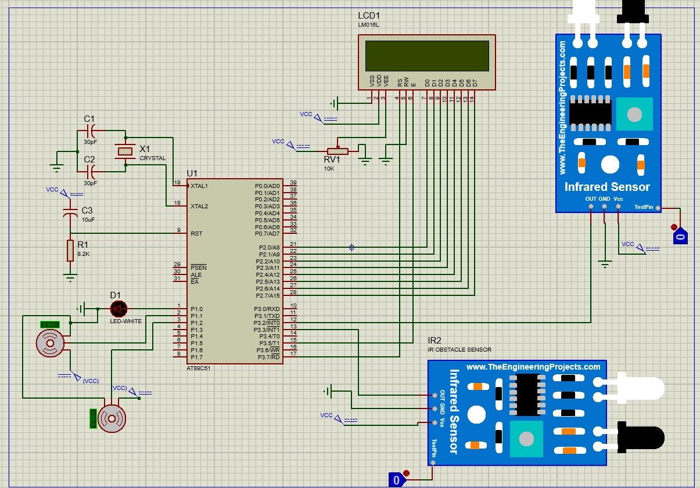

# *Hardware Project*

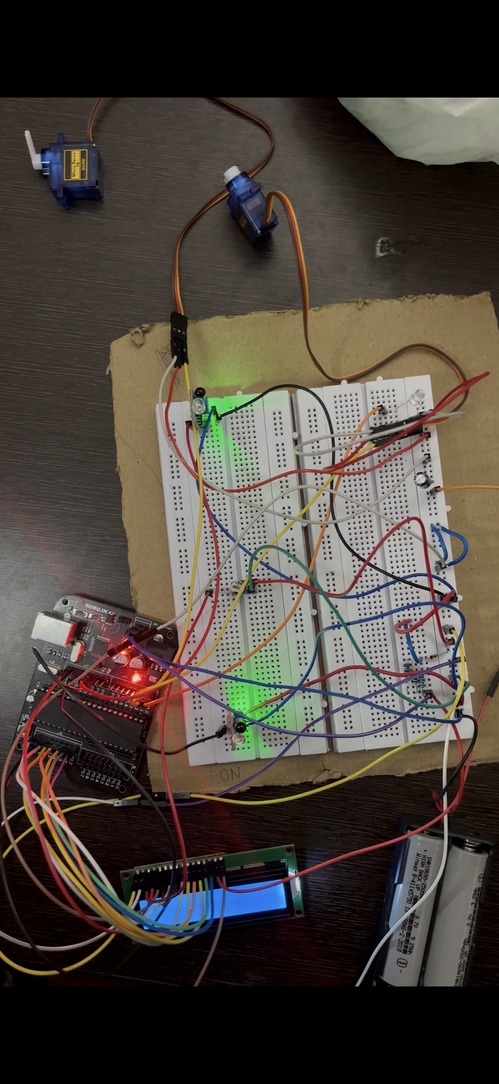

# *Outcome*

The final outcome of this project is a smart, automated energy conservation system. The system will automaticallyturnoff all connected appliances when the room is empty and automaticallyturnthemon as soon as the first person enters. The 16x2 LCD will function as a real-time display, showing the exact number of people currently inside the room.